Cross-quantilogram: NZDUSD and EURGBP
Method 20 / daily log returns / expanding quantiles / Alpari D1 full available history

Study setup
Logical pair: NZDUSD , EURGBP
Broker symbols: NZDUSD_i , EURGBP_i
Snapshot: 2026-11-03_majors_alpari_D1
Timeframe: D1
Matched return window: 1999-01-06 to 2026-11-02 (UTC bar dates)
Matched return count n: 7183
Dropped unfinished last bar dated 2026-11-03 UTC after a tick-volume check against the prior complete day.
Quantiles: expanding window, min history 252 days
tau in [0.05, 0.2]; k=0..10; headline tau=0.05, k=1
Complete matched rows (Excel): NZDUSD-EURGBP_CQ_D1.xlsx
Complete matched rows (HTML table): NZDUSD-EURGBP_CQ_D1_data.html

Method carried forward
The cross-quantilogram rho_tau(k) measures linkage among centered quantile-hit indicators of matched daily log returns of close, ln(close_t / close_t-1). Quotes are not inverted. At each date t, the tau-quantile uses only returns through t (expanding window) after a minimum history of 252 days. Hits are h_t = 1(r_t < q_t) - tau. rho_tau(k) is the normalized cross-product of h_x,t with h_y,t+k. Levels tau in {0.05, 0.20} and lags k=0..10 are pre-specified; headline is tau=0.05, k=1 both directions. Same-sample Pearson r is a side check. This is not causation and not a trading signal.

Results (headline)
rho_NZDUSD->EURGBP(tau=0.05,k=1): 0.035004
rho_EURGBP->NZDUSD(tau=0.05,k=1): 0.042276
rho_NZDUSD->EURGBP(tau=0.20,k=1): 0.030863
rho_EURGBP->NZDUSD(tau=0.20,k=1): 0.029881
Pearson r: 0.037186

CQ table (tau=0.05)
k | rho_NZDUSD_to_EURGBP | n_NZDUSD_to_EURGBP | rho_EURGBP_to_NZDUSD | n_EURGBP_to_NZDUSD
0 | 0.07864264 | 6932 | 0.07864264 | 6932
1 | 0.03500411 | 6931 | 0.0422758 | 6931
2 | 0.00227242 | 6930 | 0.01318006 | 6930
3 | 0.02407883 | 6929 | 0.02771474 | 6929
4 | 0.03134185 | 6928 | 0.04588564 | 6928
5 | 0.06042088 | 6927 | 0.03133305 | 6927
6 | 0.03496026 | 6926 | 0.01314418 | 6926
7 | 0.01677126 | 6925 | 0.01677126 | 6925
8 | 0.03130663 | 6924 | 0.03494271 | 6924
9 | 0.03493394 | 6923 | 0.03857005 | 6923
10 | 0.03856131 | 6922 | 0.03856131 | 6922

Conclusion
Headline tau=0.05, k=1 for NZDUSD and EURGBP: rho_NZDUSD->EURGBP = 0.0350; rho_EURGBP->NZDUSD = 0.0423. At tau=0.20, k=1: 0.0309 and 0.0299. Same-day tau=0.05 rho(k=0) = 0.0786. Pearson r = 0.0372. This is quantile-hit linkage, not a trading signal.

Charts
Daily closes

Daily log returns

Cross-quantilogram tau=0.05
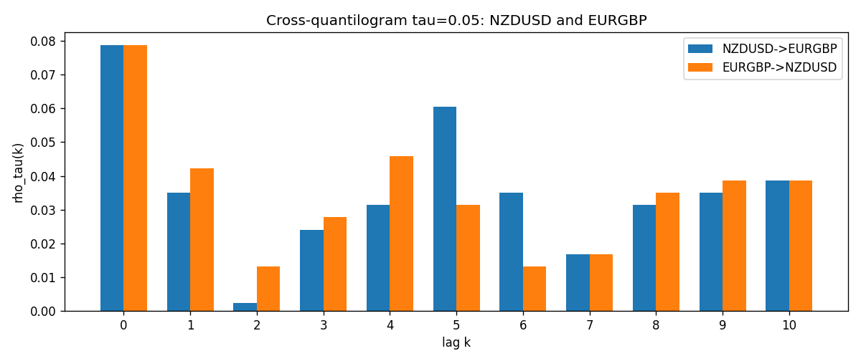

Data report
Matched rows and the CQ sheet are in the sibling Excel workbook named NZDUSD-EURGBP_CQ_D1.xlsx. Embedding all rows as a Word table is impractical; this file holds column summaries and the first and last 15 matched rows.
Columns: time, NZDUSD_open, EURGBP_open, NZDUSD_high, EURGBP_high, NZDUSD_low, EURGBP_low, NZDUSD_close, EURGBP_close, NZDUSD_tick_volume, EURGBP_tick_volume, NZDUSD_spread, EURGBP_spread, NZDUSD_real_volume, EURGBP_real_volume, NZDUSD_log_return, EURGBP_log_return, NZDUSD_h_t005, EURGBP_h_t005
Column summaries (matched calculation rows)
column | count | mean | std | min | 25% | 50% | 75% | max
NZDUSD_open | 7183 | 0.65646991 | 0.10818219 | 0.3913 | 0.591455 | 0.6684 | 0.72495 | 0.88218
EURGBP_open | 7183 | 0.78694248 | 0.0966971 | 0.5734 | 0.68755 | 0.83389 | 0.86522 | 0.9769
NZDUSD_high | 7183 | 0.66038812 | 0.10867344 | 0.3961 | 0.5949 | 0.67204 | 0.729365 | 0.88421
EURGBP_high | 7183 | 0.7900202 | 0.09707133 | 0.5789 | 0.6896 | 0.8369 | 0.8681 | 0.9799
NZDUSD_low | 7183 | 0.65278196 | 0.10777661 | 0.3897 | 0.58816 | 0.6642 | 0.720985 | 0.87988
EURGBP_low | 7183 | 0.78424251 | 0.0965143 | 0.5682 | 0.6855 | 0.83166 | 0.86287 | 0.9661
NZDUSD_close | 7183 | 0.65654354 | 0.10817679 | 0.3907 | 0.59181 | 0.6685 | 0.72502 | 0.8822
EURGBP_close | 7183 | 0.78698724 | 0.09669475 | 0.5735 | 0.68775 | 0.83395 | 0.86536 | 0.977
NZDUSD_tick_volume | 7183 | 68736.568 | 123152.54 | 16 | 5594.5 | 33901 | 58513.5 | 1127682
EURGBP_tick_volume | 7183 | 87133.158 | 145499.84 | 154 | 6553 | 44358 | 81413 | 1424684
NZDUSD_spread | 7183 | 30.260755 | 25.633067 | 0 | 9 | 17 | 40 | 80
EURGBP_spread | 7183 | 21.328832 | 19.122264 | 0 | 4 | 13 | 40 | 50
NZDUSD_real_volume | 7183 | 1.6708354e+10 | 8.49951e+10 | 0 | 0 | 0 | 0 | 2.705649e+12
EURGBP_real_volume | 7183 | 2.7872287e+10 | 1.3521454e+11 | 0 | 0 | 0 | 0 | 3.5726265e+12
NZDUSD_log_return | 7183 | 1.073e-05 | 0.0076464 | -0.07027433 | -0.00425909 | 0.00022967 | 0.00458236 | 0.05966839
EURGBP_log_return | 7183 | 2.33e-05 | 0.00487088 | -0.03067367 | -0.00262163 | -9.879e-05 | 0.002558 | 0.06075387
NZDUSD_h_t005 | 6932 | -0.00571264 | 0.20574766 | -0.05 | -0.05 | -0.05 | -0.05 | 0.95
EURGBP_h_t005 | 6932 | -0.01148298 | 0.19245468 | -0.05 | -0.05 | -0.05 | -0.05 | 0.95
First 15 matched rows (selected columns)
time | NZDUSD_log_return | EURGBP_log_return | NZDUSD_h_t005 | EURGBP_h_t005
1999-01-06 | 0.0020455609 | -0.013303338 | nan | nan
1999-01-07 | 0.0062963171 | 0.011051402 | nan | nan
1999-01-08 | -0.00055396548 | -0.004943862 | nan | nan
1999-01-11 | 0.010290425 | -0.0012752393 | nan | nan
1999-01-12 | -0.0053157489 | 0.0033970309 | nan | nan
1999-01-13 | -0.0099742238 | 0.00042381861 | nan | nan
1999-01-14 | -0.00018564931 | -0.0019793588 | nan | nan
1999-01-15 | -0.00074294208 | -0.0076715819 | nan | nan
1999-01-18 | -0.0018597736 | 0.00071280921 | nan | nan
1999-01-19 | 0.0018597736 | -0.0014261269 | nan | nan
1999-01-20 | 0.0040793678 | 0.0019960086 | nan | nan
1999-01-21 | 0.0040627941 | -0.00071240297 | nan | nan
1999-01-22 | -0.012051689 | -0.0017118406 | nan | nan
1999-01-25 | -0.0035504102 | -0.0054402425 | nan | nan
1999-01-26 | 0.0072741158 | -0.00057438255 | nan | nan
Last 15 matched rows (selected columns)
time | NZDUSD_log_return | EURGBP_log_return | NZDUSD_h_t005 | EURGBP_h_t005
2026-10-13 | 0.0047326165 | 0.00020130374 | -0.05 | -0.05
2026-10-14 | -0.0037306483 | 0.0011241873 | -0.05 | -0.05
2026-10-15 | 0.0047634855 | -0.00087557391 | -0.05 | -0.05
2026-10-16 | 0.0057501001 | -0.0020380844 | -0.05 | -0.05
2026-10-19 | 0.0018917133 | -0.00056950988 | -0.05 | -0.05
2026-10-20 | 0.0037199341 | -0.0035906254 | -0.05 | -0.05
2026-10-21 | 0.0030923331 | -0.00140647 | -0.05 | -0.05
2026-10-22 | -0.0033035227 | -0.0018743924 | -0.05 | -0.05
2026-10-23 | 0.0030929853 | 0.00082421033 | -0.05 | -0.05
2026-10-26 | -0.0028993932 | 0.00013133309 | -0.05 | -0.05
2026-10-27 | -0.00026399852 | -0.0019957343 | -0.05 | -0.05
2026-10-28 | -0.0097283914 | 0.00066967224 | -0.05 | -0.05
2026-10-29 | 0.00062190714 | -0.0011722209 | -0.05 | -0.05
2026-10-30 | 0.00019537668 | -0.0024205543 | -0.05 | -0.05
2026-11-02 | -0.0025962955 | 0.00089940465 | -0.05 | -0.05

